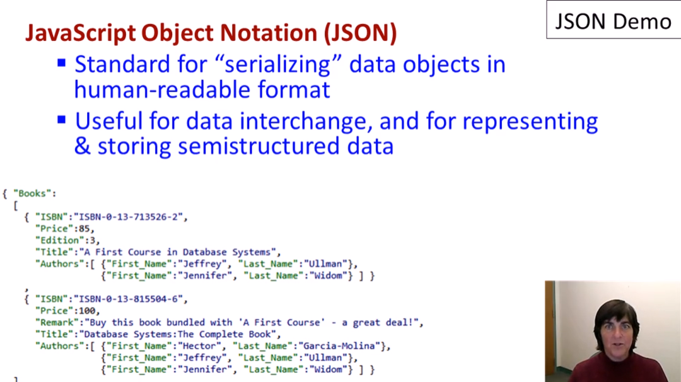

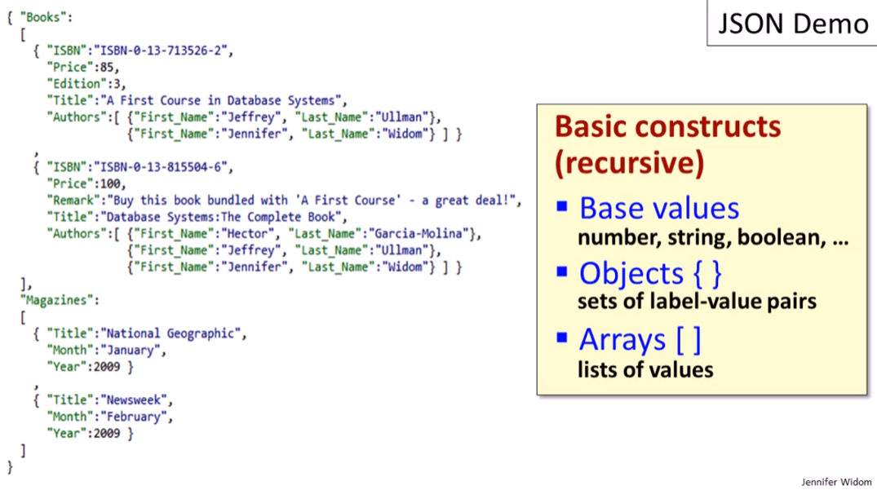

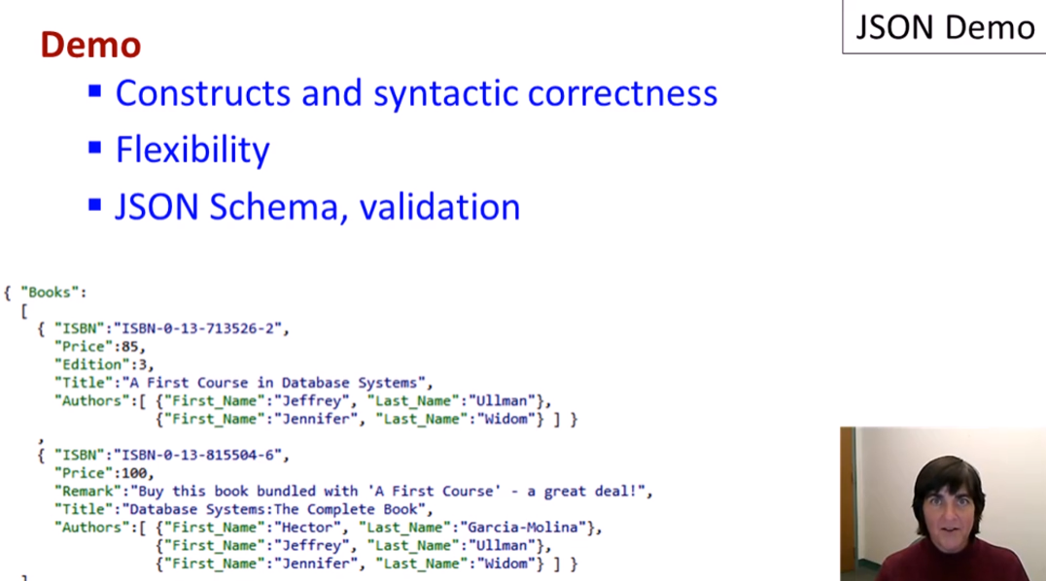

@Chrome Browser

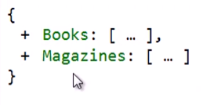

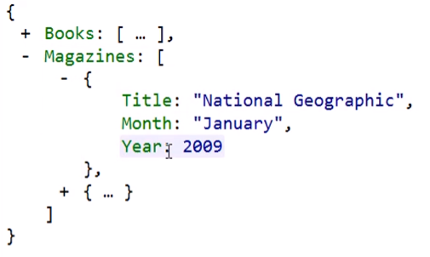

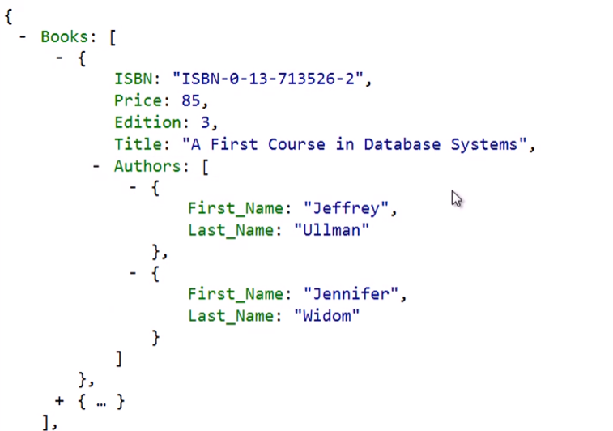

* You can collapse objects to see structure

**SYNTACTIC CORRECTNESS**

Missed comma error:

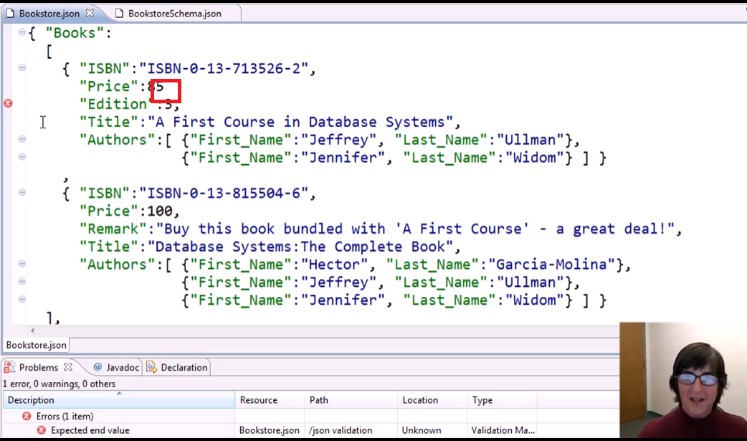

Extra braces error:

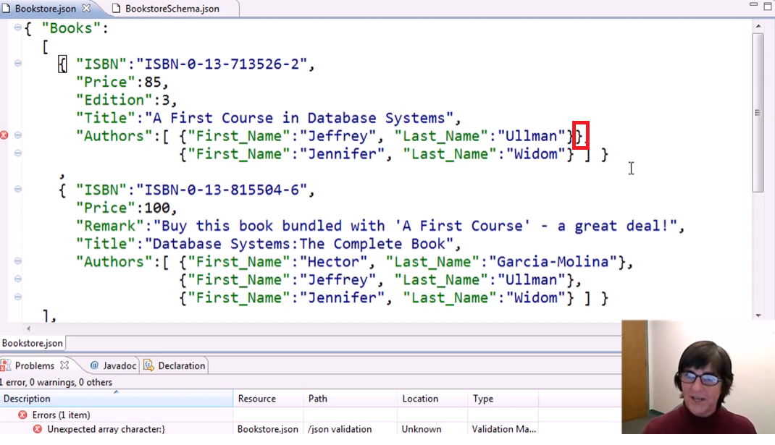

No quotes around value strings error:

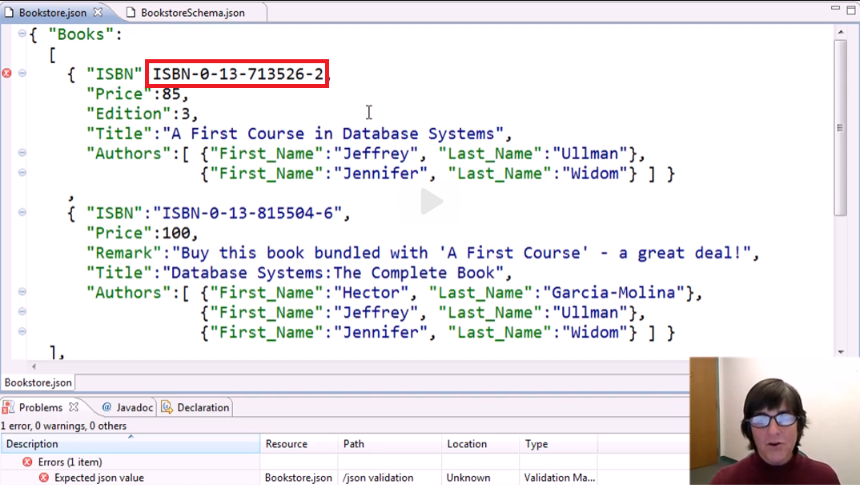

No quotes around label strings error:

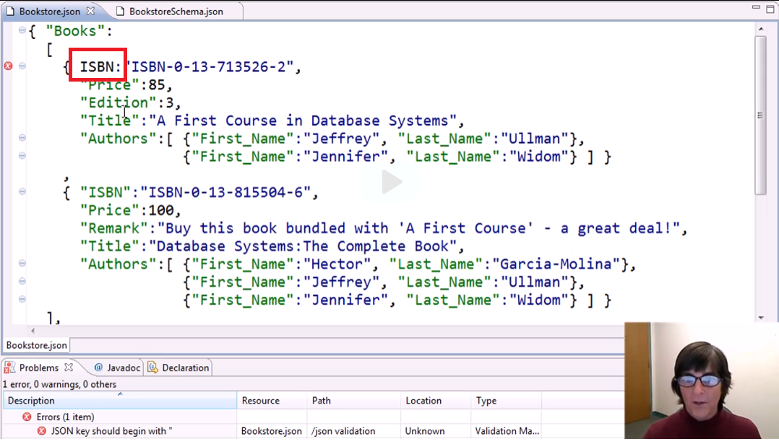

Quoting a number:

* Not an error, but changed data type from number to string

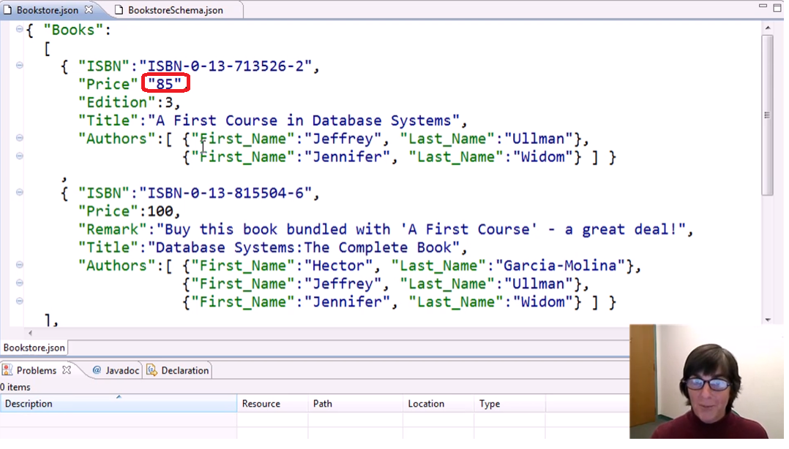

Boolean values

* Reserved for json
  + true
  + false

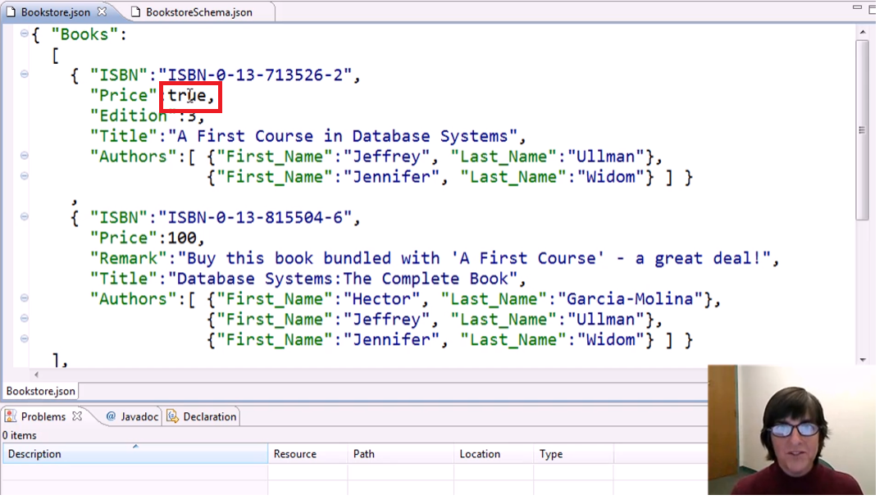

Null values

* Reserved for json
  + null

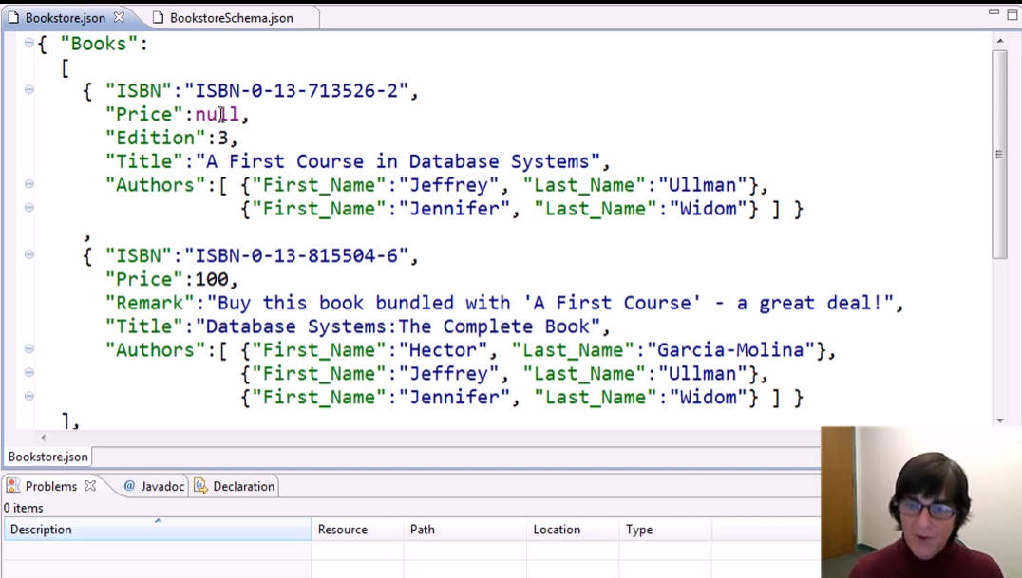

Using nil Error

* Not a reserved word

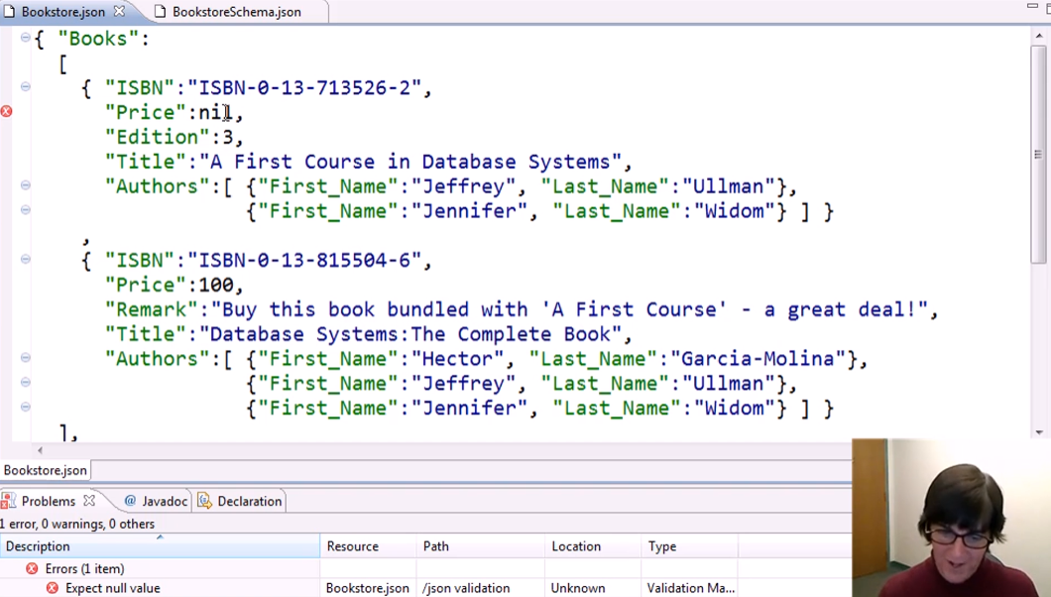

* Quote as string if you really want to use nil

Arrays can have different types inside it:

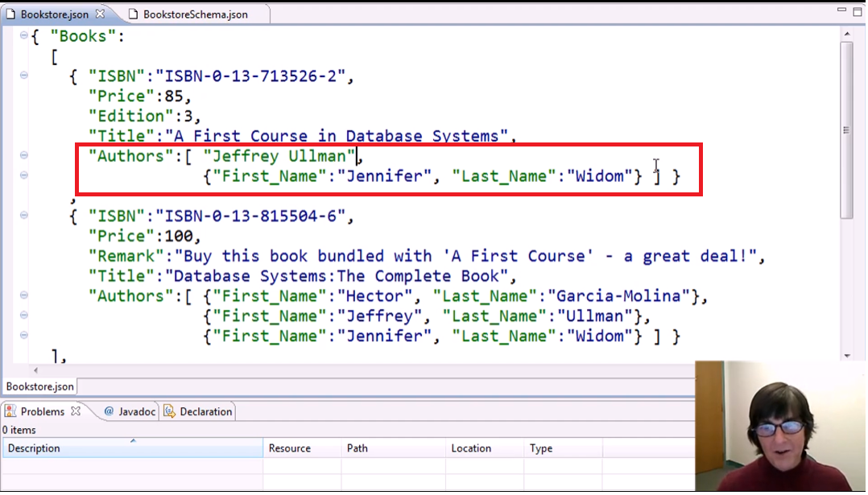

Arrays can also have empty objects:

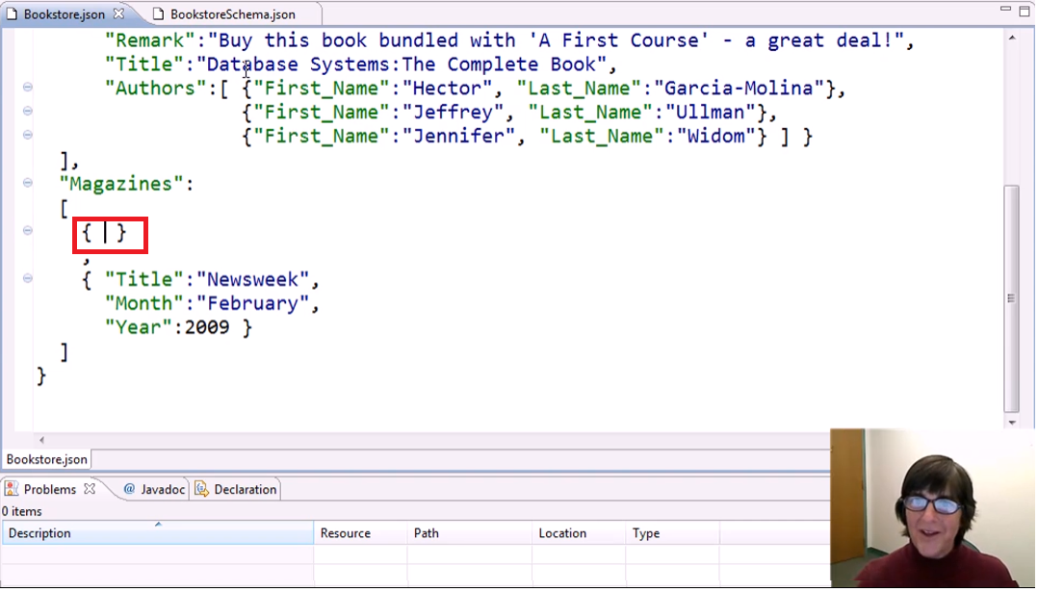

Arrays can have 0 length:

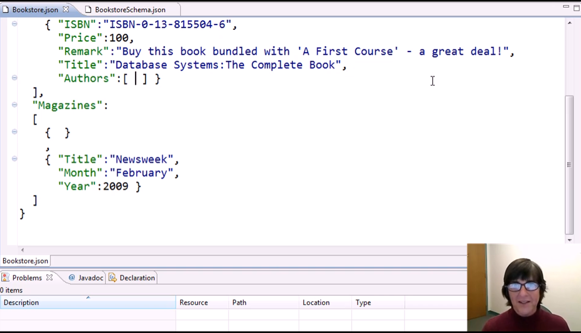

Taking out the value itself for “Authors” label (Object not having a key-value pair)

* Syntactically wrong

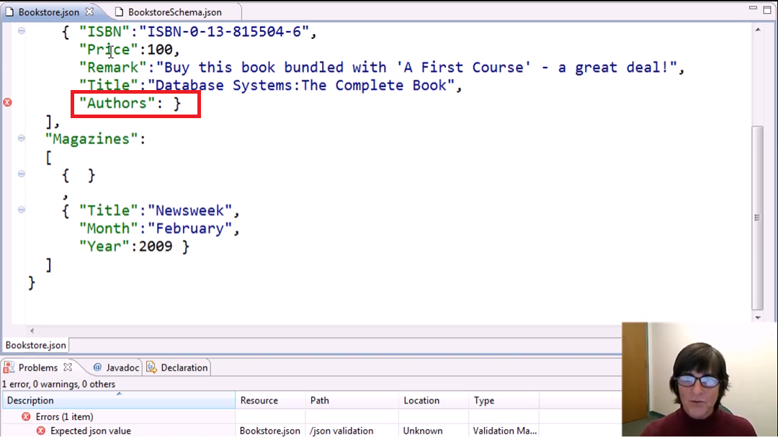

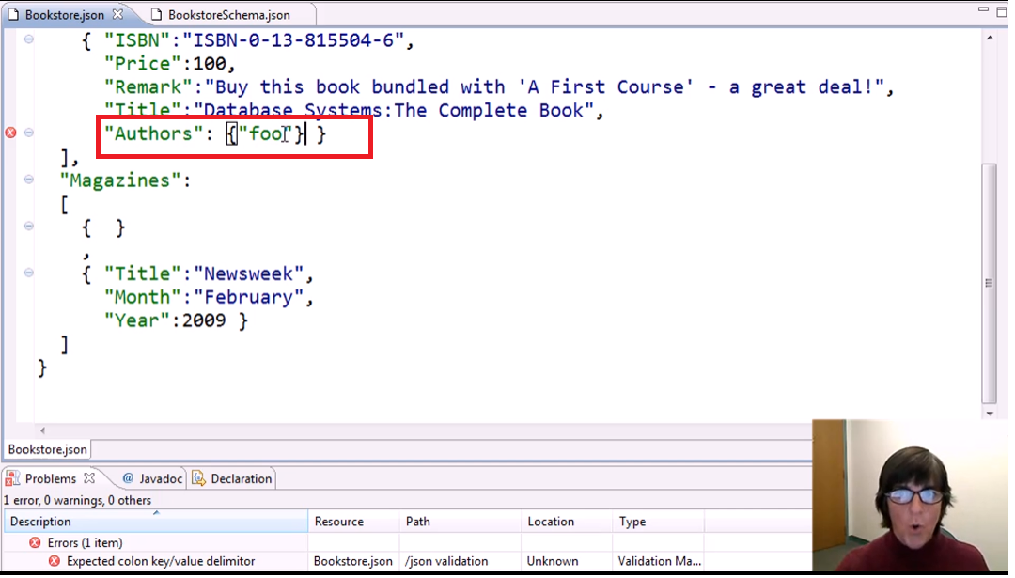

**USING JSON SCHEMAS** **FOR SEMANTIC CORRECTNESS**

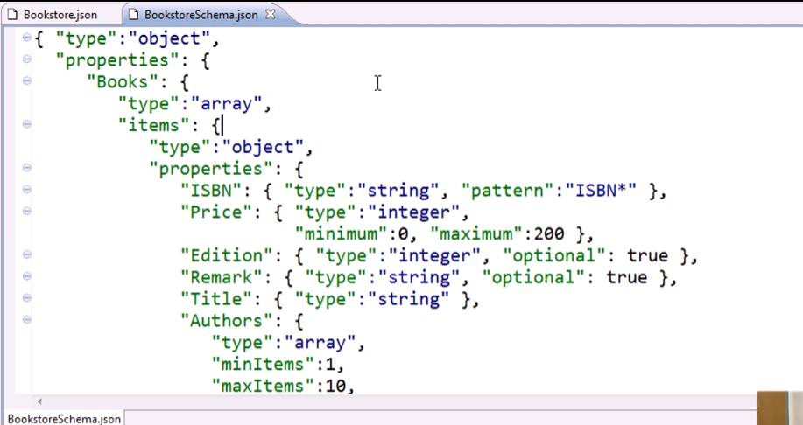

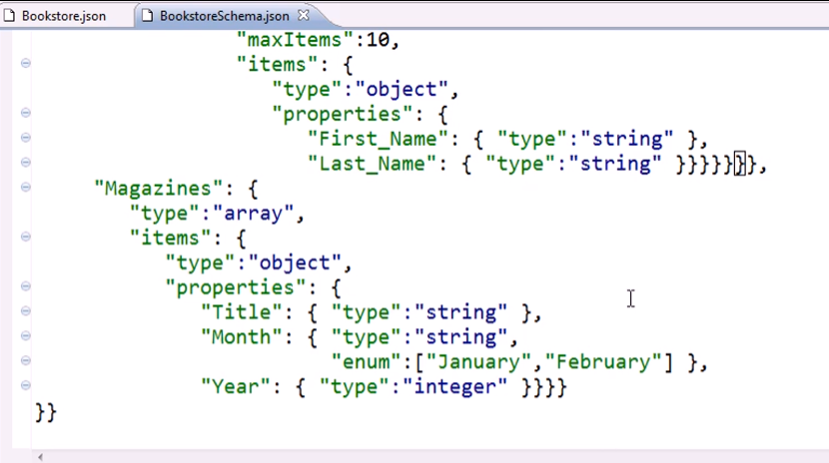

Online JSON Data Validator

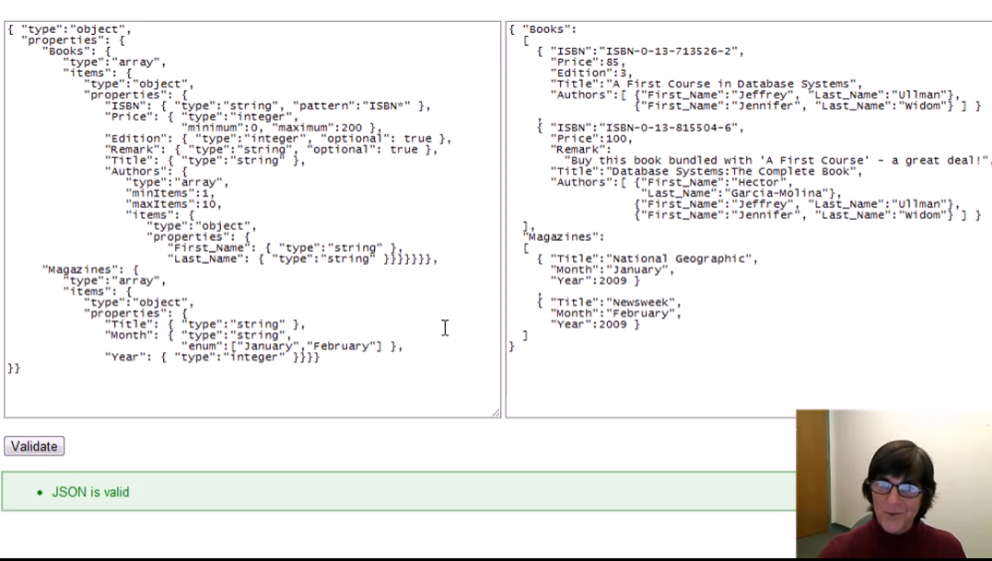

Basic syntactic errors

* Removing commas

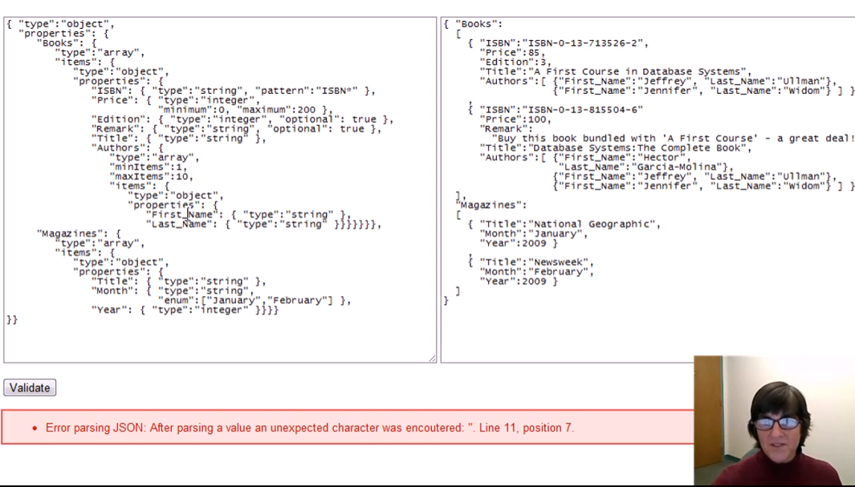

*Validating Semantics*

Integer Types

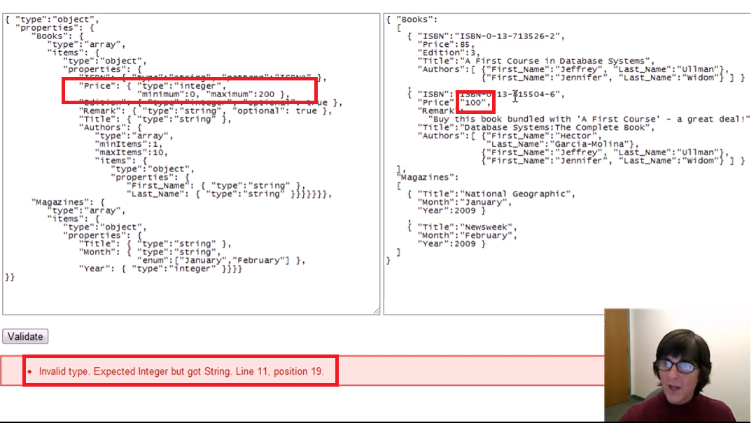

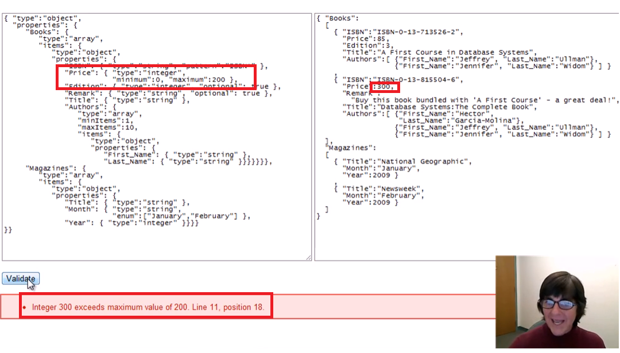

String types

Using “pattern” constraint

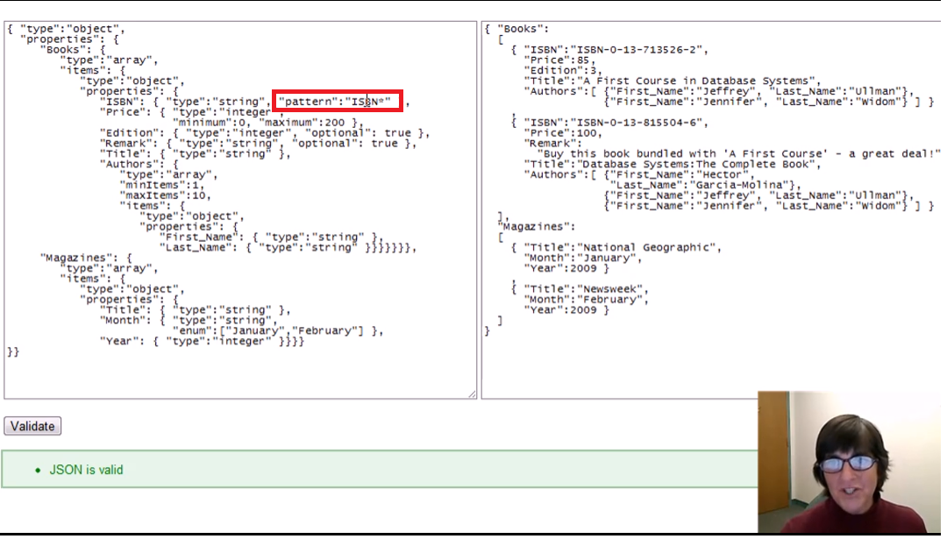

Mismatching the pattern

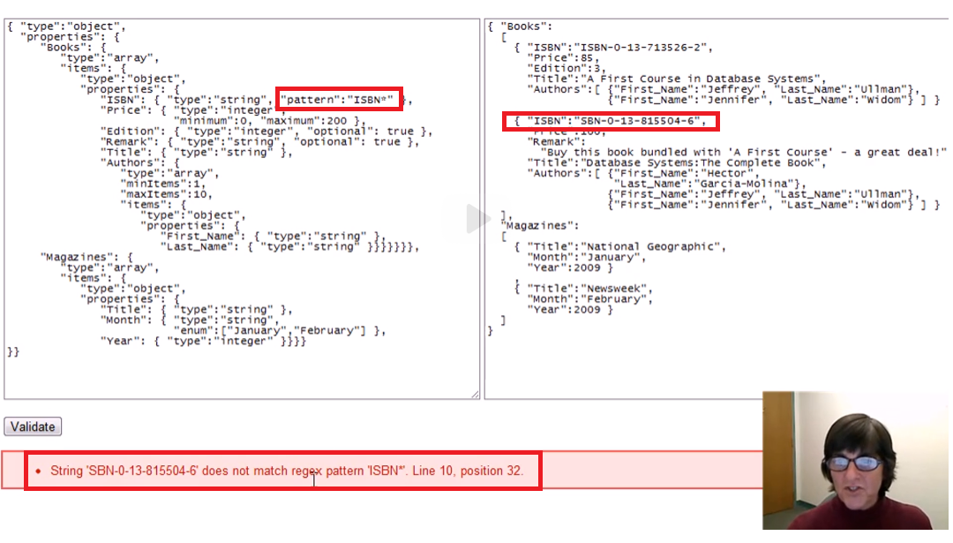

minItems and maxItems in Arrays

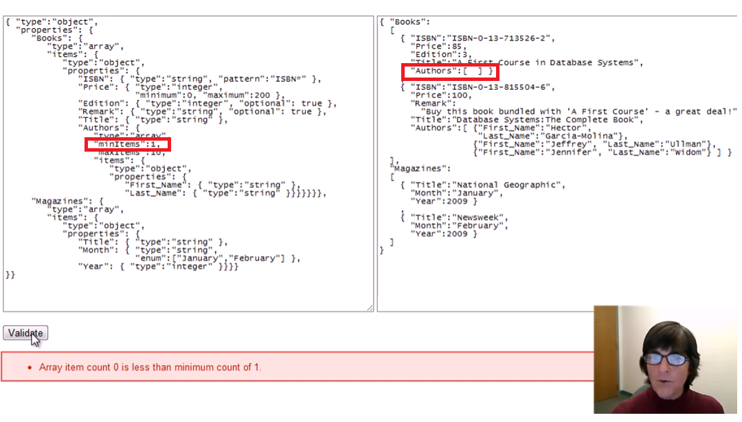

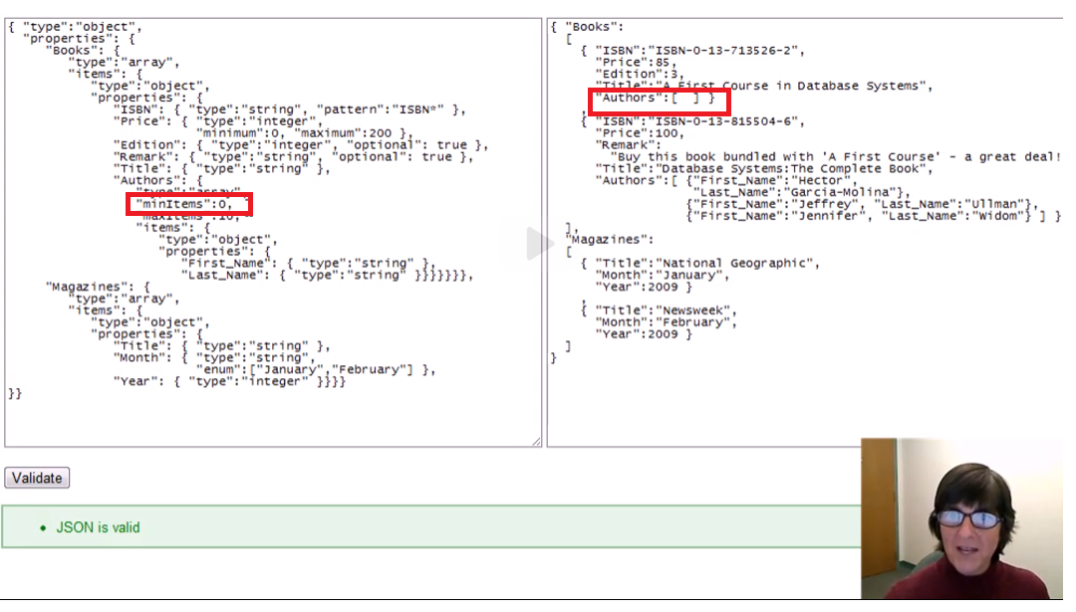

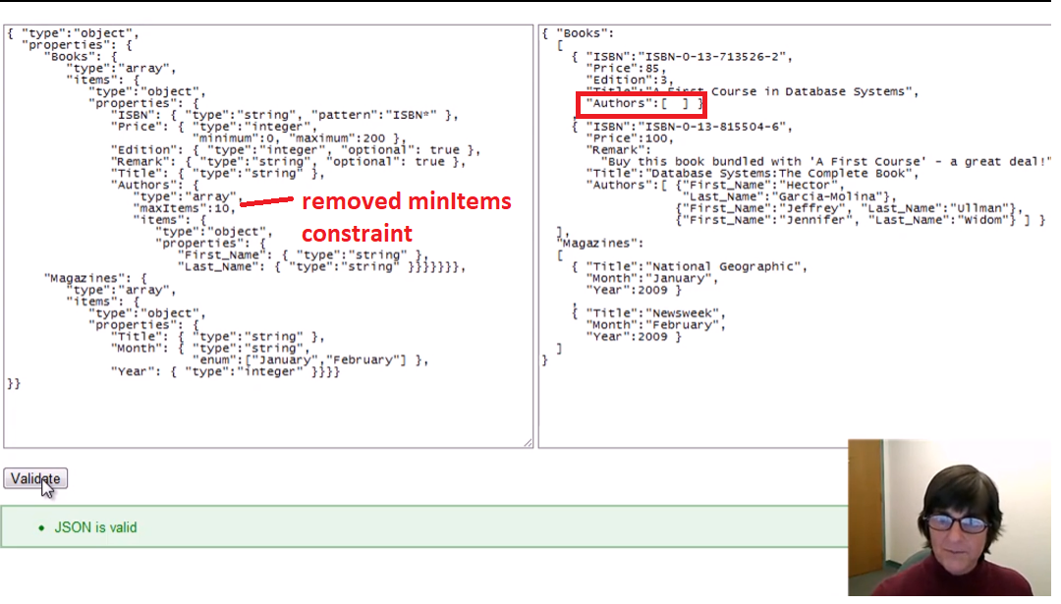

Adding a property that is NOT in the schema:

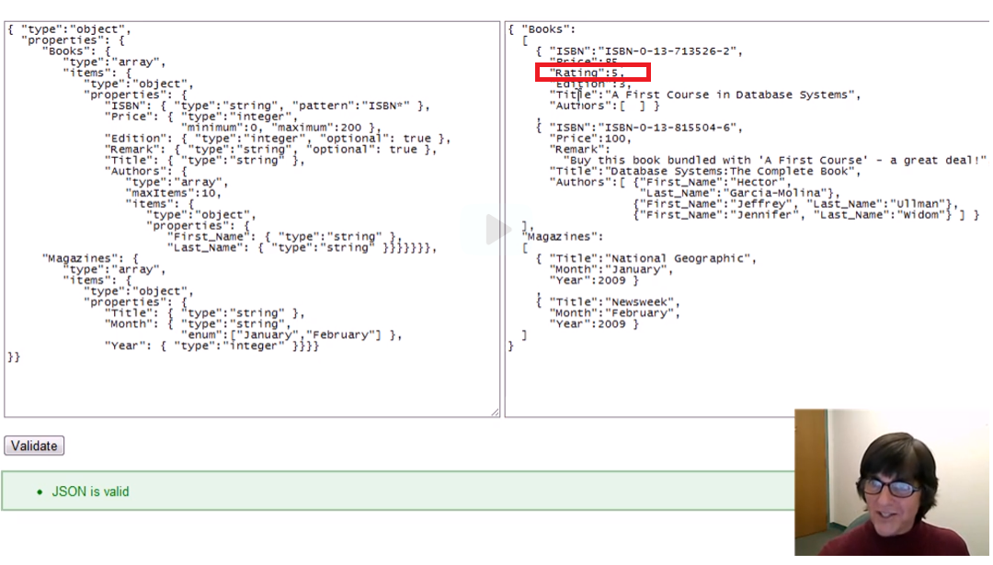

* Still valid
* JSON Schema just constrain things that are present in the JSON Schema but it is flexible as to add other properties in our JSON that are not present in the JSON Schema

Adding constraint to the schema to STRICTLY follow the properties that are only present in the JSON Schema

* “additionalProperties”: false

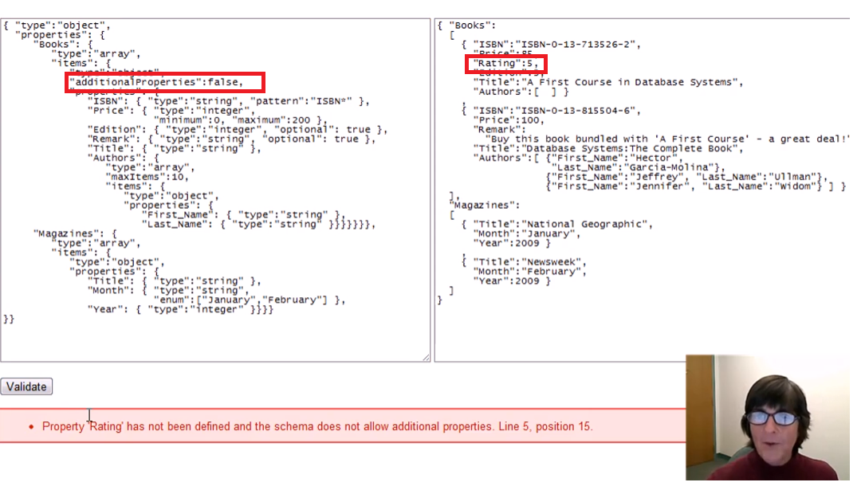

Removing “First_name” as a property in the Authors array

* “First_name” is not optional here

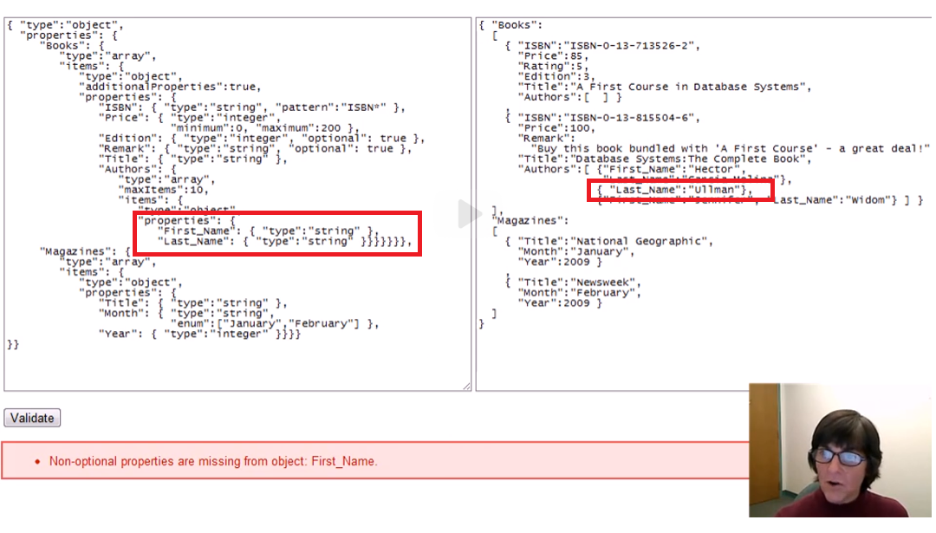

Making a property as optional:

* “optional”: true

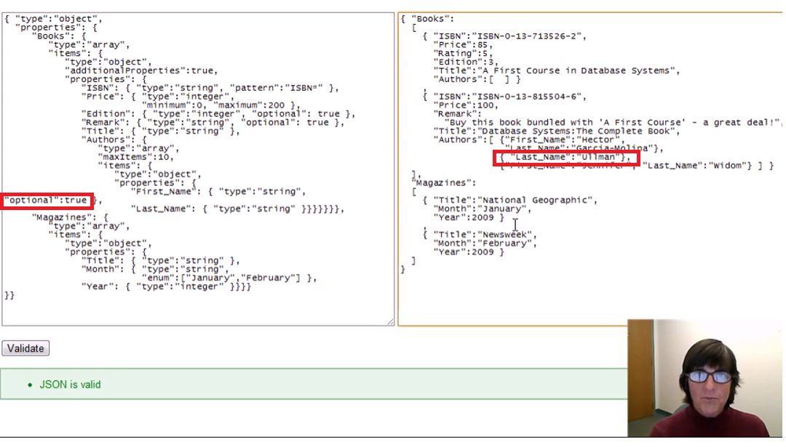

Adding the same property twice inside the same object

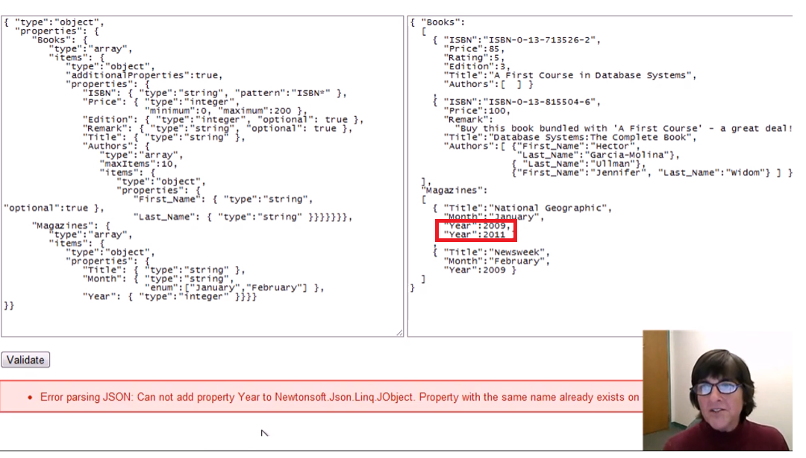

“enum” constraint

* Values that are allowed

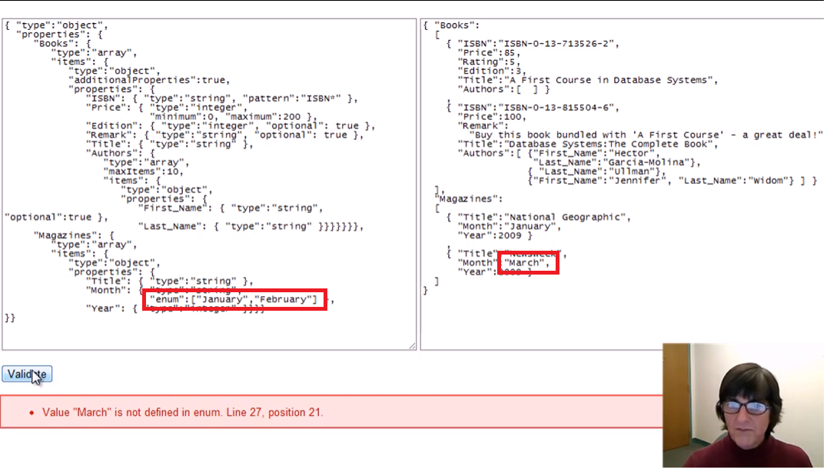

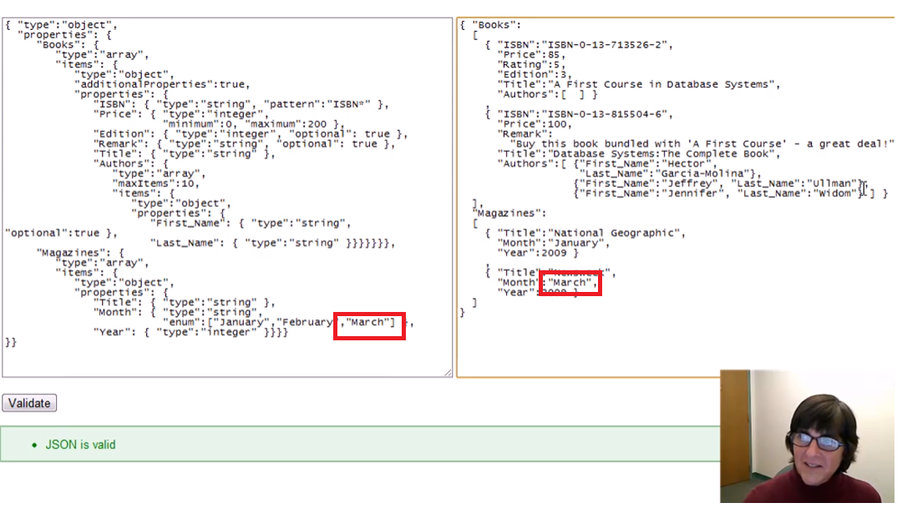

Wrong data type in Arrays:

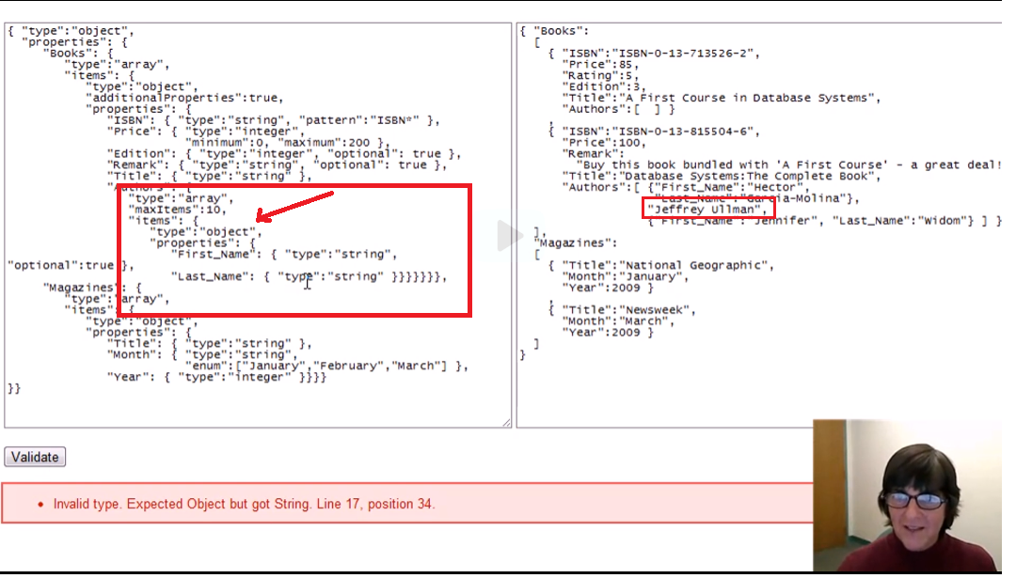

Allowing different types

* Making the value for the “type” constraint be an array

